**iMX8M_HMI_Platform**

**BATCH-1 ASSEMBLY ISSUE REPORT (20 BOARDS)**

**PCB ASSEMBLED DATE – 19/11/2018**

**ASSEMBLY LOCATION: PODRAIN, Bangalore**

**Issue-1 - Mechanical Pin of Panel connectors are not soldered in multiple boards. We had to do manual touch up in house**

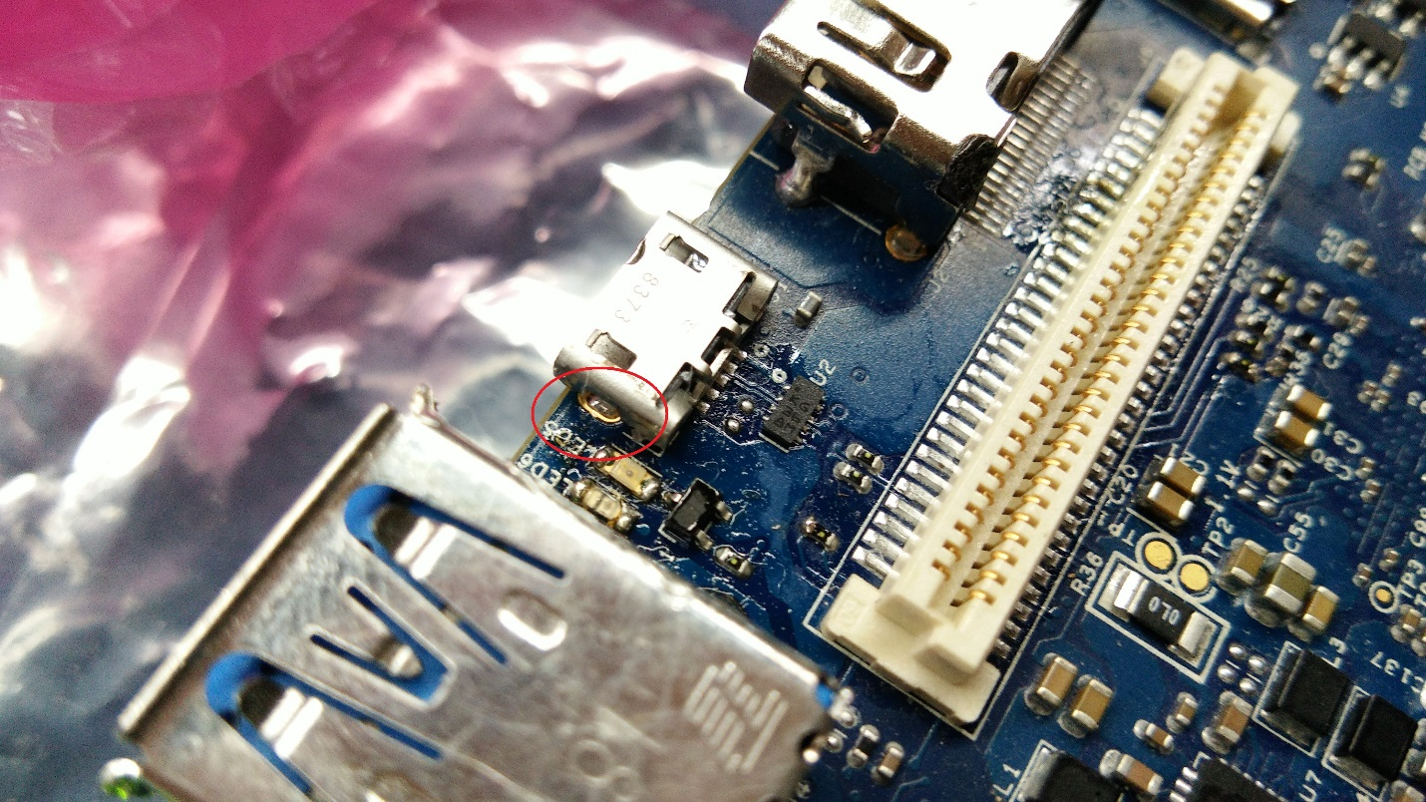

**Issue-2 – In multiple boards we have faced issue of dry solder on connectors J6 and J7.**

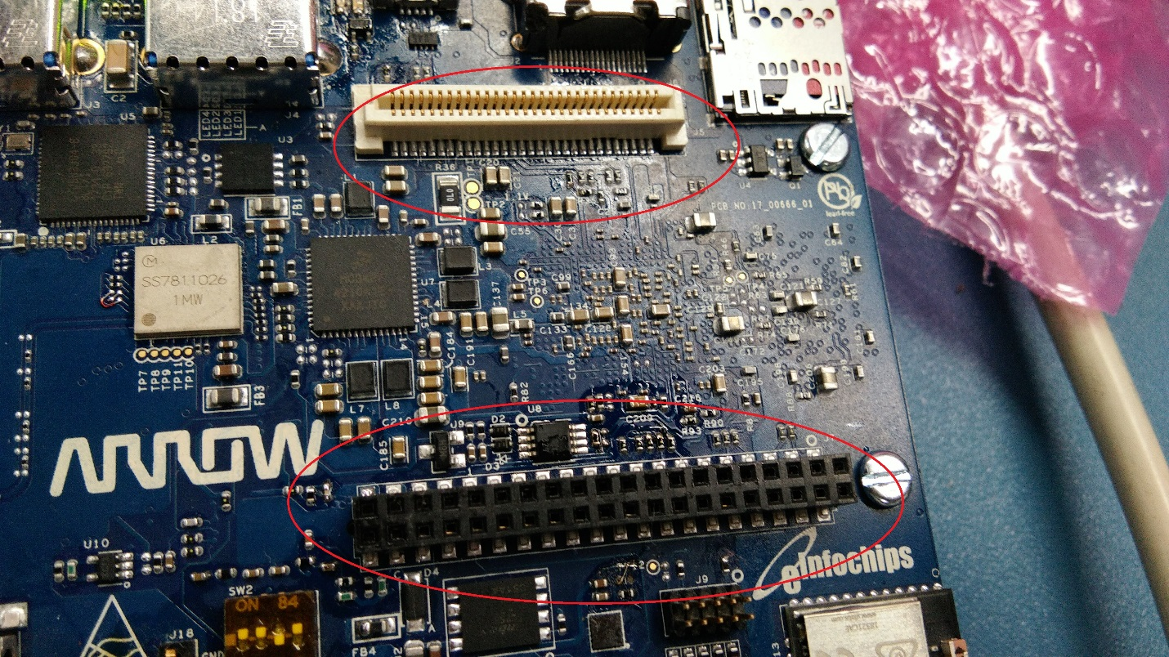

**Issue-3 – Crystal Y2 was having dry solder issue in multiple boards.**

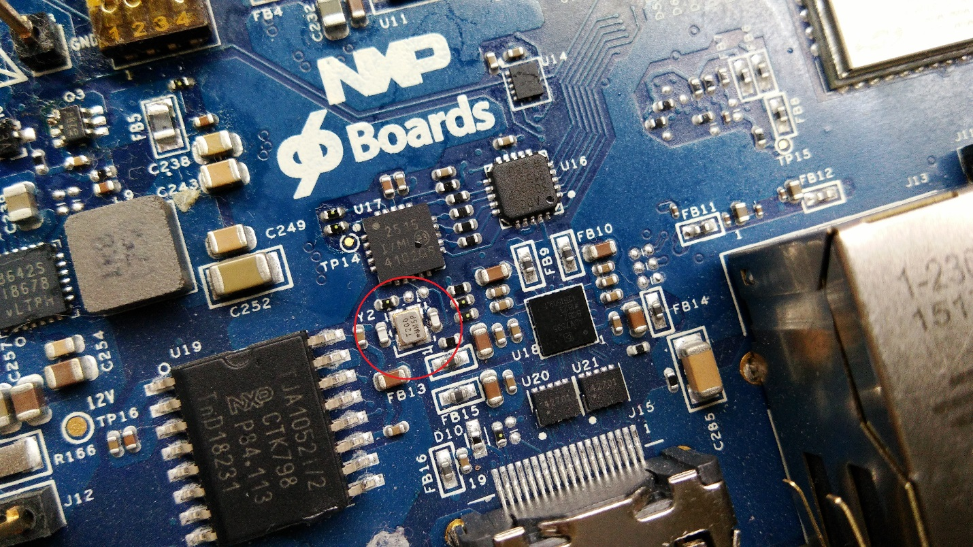

**Issue-4 – In multiple boards two (U5 & U58) IC were not soldered properly though it was of QFN package. We had to heat them to make it functional.**

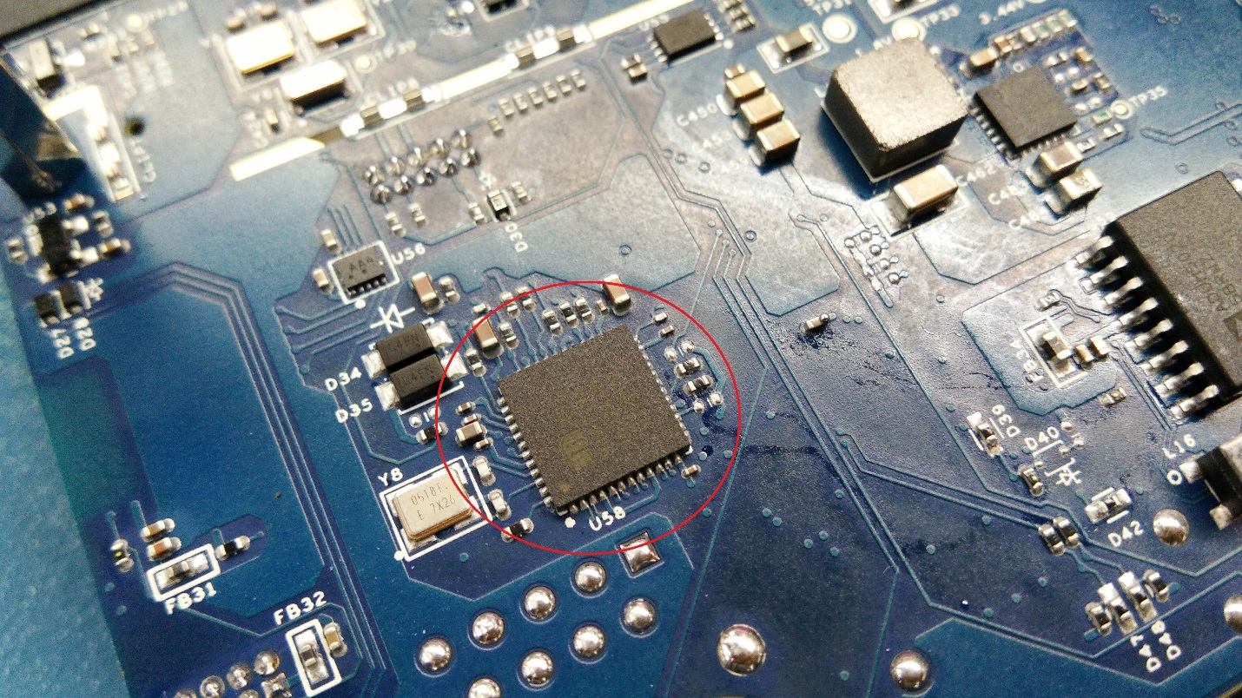

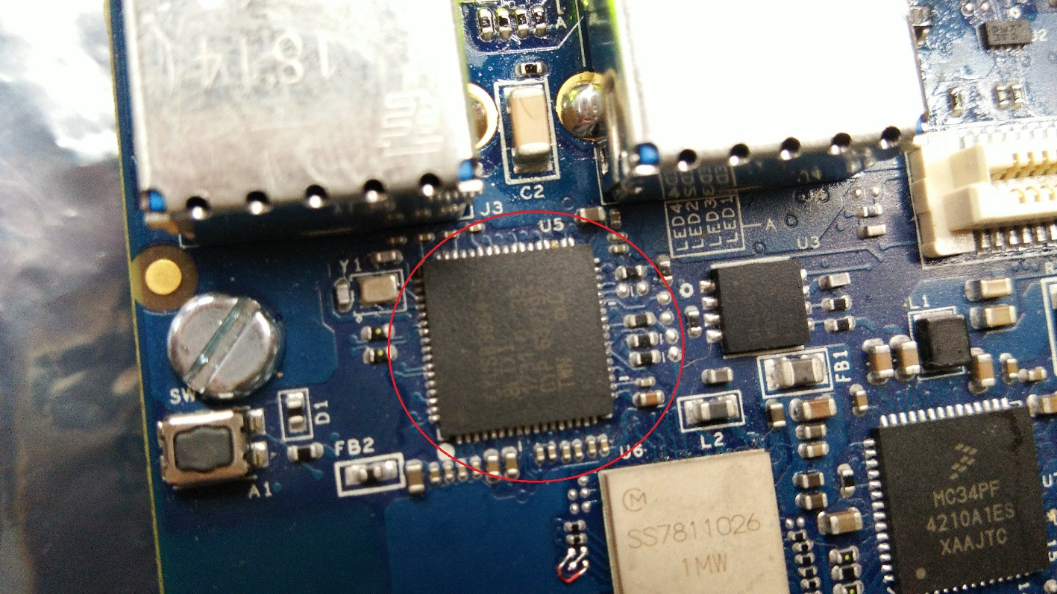

**Issue-5 –In one board one of the capacitor’s pad was not soldered.**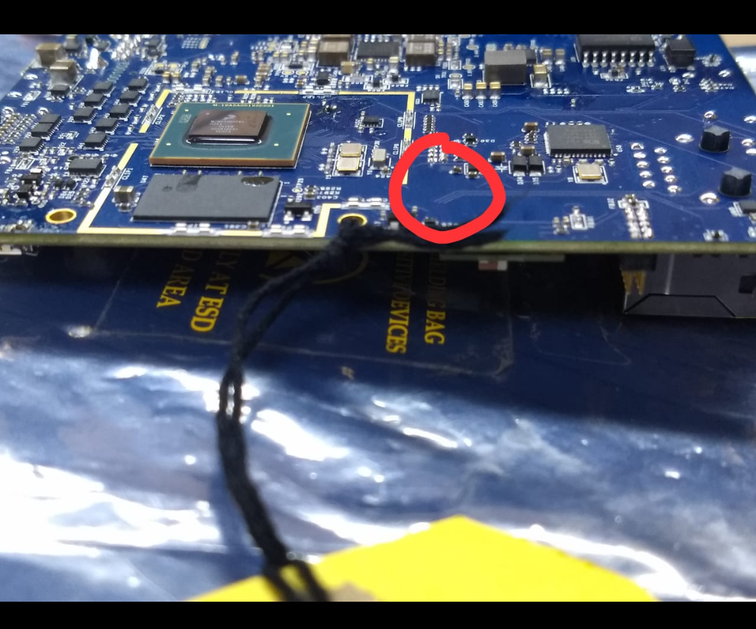

**Issue-6–In one of the boards 3 discrete components were mounted which are supposed to be DNP. Such issues are critical and may result in non-functionality of the board.**

**Issue-7 –In one board HDMI connector (J2) was mounted bit offset.**

